



Matrimony App

(Android)

Documentation

By Sharp Flux Technologies

­­

**TABLE OF CONTENTS**

Project Definition 3

Purpose of Application 3

Matrimony APP Modules 3

Stakeholders 3

Flowchart 3

Conclusion 3



# Project Definition

What is Matrimonial Application?

* The main objective of Matrimonial Application is to provide Grooms and Brides with excellent matchmaking experience by exploring the opportunities and resources to meet true potential partner
* Keeping our objective in mind, we have created a world renowned online matchmaking services that will touch the souls of millions of people all over the globe

# Purpose of Application

* The main purpose of this application is to facilitate matchmaking business by applying the information in the field
* It helps the user by providing profiles of perspective “Bride” or “Groom” and other information regarding them online
* User can get information regarding their dream life partner at his/her home at his/her convenience
* This application also provides a search utility which helps those users who have a certain criteria of qualities in mind to make online matrimonial easier
* Since internet is a pivot for modern business, our project which is based on internet paves a path for modernization in trade

# Matrimony APP Modules

Register:

* User provides some basic information like Name, Number, Email Id, Password, Age, etc. while registering

Login:

* User logs in with a valid mobile number and password
* User can re-set the password using registered mobile number by clicking the “Forgot Password”
* New users can register by clicking “Create account”

Home:

* Home page will display a list of profiles based on partner preference
* By clicking “View Profile” users get to know detailed information of interested profiles
* By clicking “Send Interest” users request interested profiles in order to show their interest
* Profiles to whom interest has been sent are listed under “Interest Sent” screen
* Also “Received Interest” tab would contain list of profiles who have shown interest
* Home page also contains navigation menu which includes the following
* Home
* Search
* Interest Sent
* Chats/Messages
* Membership Plan
* Profile
* Edit Profile
* Upload Images
* Logout

Search:

* Users can search by applying filters like
  + Age group
  + Religion
  + Mother tongue
  + Caste
  + Area
  + Marital Status, etc.

Interest Sent:

* This screen contains list of profiles to whom interest has been sent
* By clicking “View Profile” then users can view full details of that profile

Membership Plan:

* This screen shows list of membership plans
* After selecting a plan user is navigated to payment gateway

My Profile:

* User can view their profile by clicking “Profile” in navigation
* Users can also update their profile and change partner preferences
* Profile includes following :
* Personal details
* Qualification
* Career details
* Family details
* Contact details
* Religious details
* Gothram and Star details
* Physical appearance
* Life style

Gallery:

* Users can set their profile pic
* Users can upload multiple pictures

# STAKEHOLDERS

**Project stakeholders** are entities / people that have an interest in a given project. These stakeholders may be inside or outside an organization which:

* Sponsor a project or
* Have an interest or a gain upon a successful completion of a project
* May have a positive or negative influence in the project completion

The following are **Stakeholders of Matrimony App**:

* Admin
* Members(Paid Members)
* Visitors(Free Members)

Admin Profile:

* Login
* Add new Bride / Groom
* Update existing Bride / Groom’s details
* Approve a success story
* Post Success stories
* Activate / deactivate a profile
* Logout

Membership Profile (Paid):

* Register
* Login
* Add details such as :
  + Personal
  + Qualification
  + Career
  + Family
  + Religious
  + Lifestyle
  + Address
  + Gothram
  + Physical Appearance
* Set profile privacy (e.g. Public, private or mutual)
* Can Send Interest to paid as well as free profiles
* Receive Interest from only paid profiles
* Add Partner Preferences
* Search profiles by id / username
* Search by applying filters like age group, salary, religion, caste, area, etc.
* Block inappropriate profiles
* View Success stories
* Receive notifications
* Online chat
* Save profiles as favorite
* Logout
* Deactivate my profile

Visitor’s Profile (Free):

* Register
* Login
* Add details such as :
  + Personal
  + Qualification
  + Career
  + Family
  + Religious
  + Lifestyle
  + Address
  + Gothram
  + Physical Appearance
* Set profile privacy (e.g. Public, private or mutual)
* Can Send Interest to free profiles only
* Receive Interests from paid as well as free profiles
* View Success stories
* Receive notifications
* View Success stories
* Logout
* Deactivate my profile

# Flowchart

Flowchart (Admin):

Start

Admin

Login

No

Yes

Add Bride/ Groom

Update Bride/ Groom

Approve and post Success Stories

Deactivate profiles

Stop

Logout

Start

Flowchart (Member):

Member

No

Registration

Yes

Login

No

Yes

Is Paid membership?

Yes

Online Chat

Block profiles

Save profiles as favorites

Search by filters

View success stories

Send Follow Request

Update Profile

View Profile

My Profile

Approve Request

Conti. Flowchart (Member):

Logout

Search by id

Receive notifications

Stop

Flowchart (Visitor):

View Public Profiles

Visitor

View Success Stories

Start

Stop

# Screenshots

**Login**

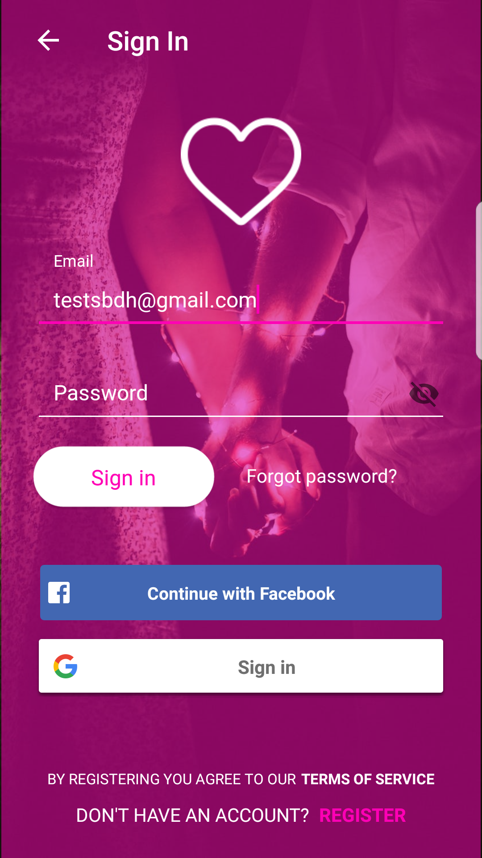

**Register**

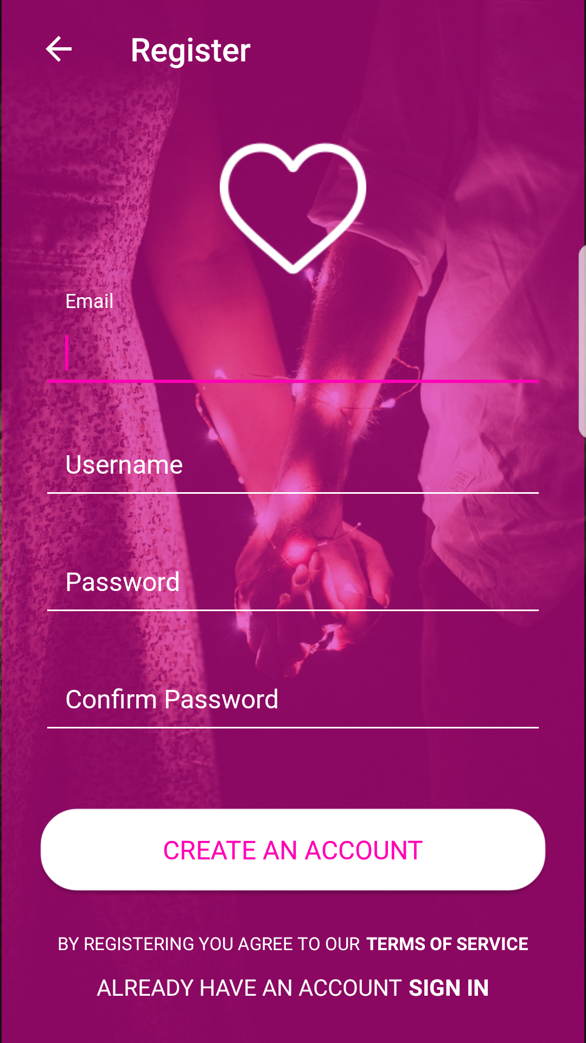

**Set Preferences**

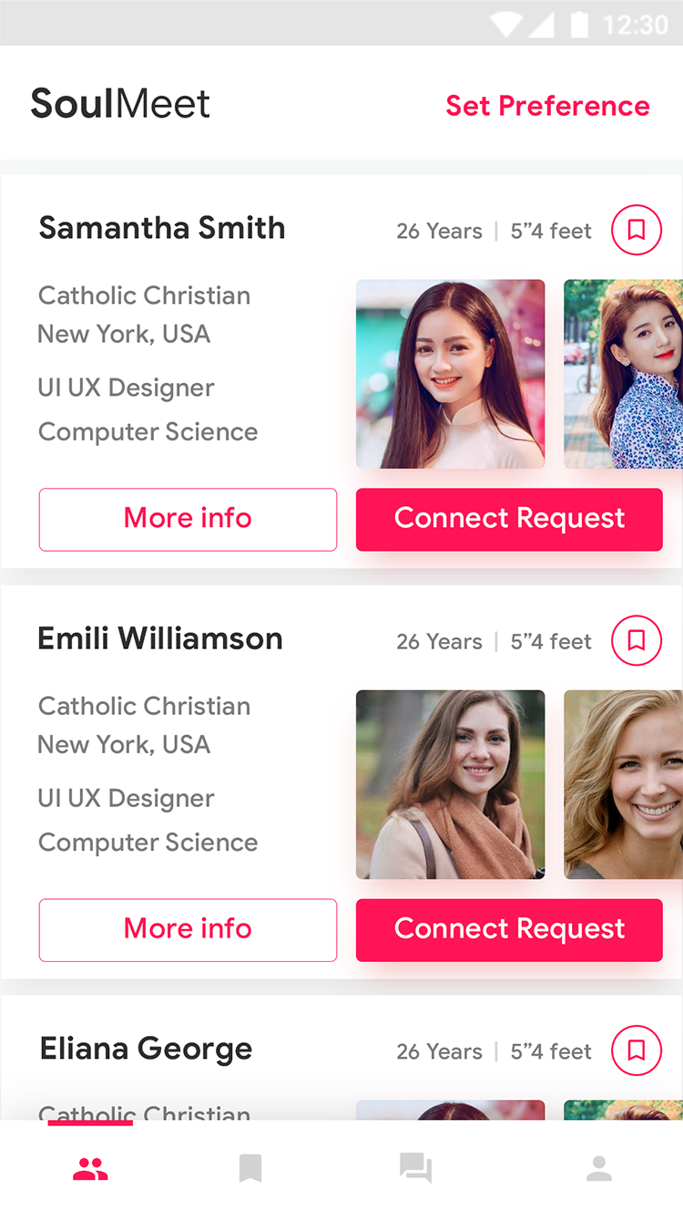

**View Profile**

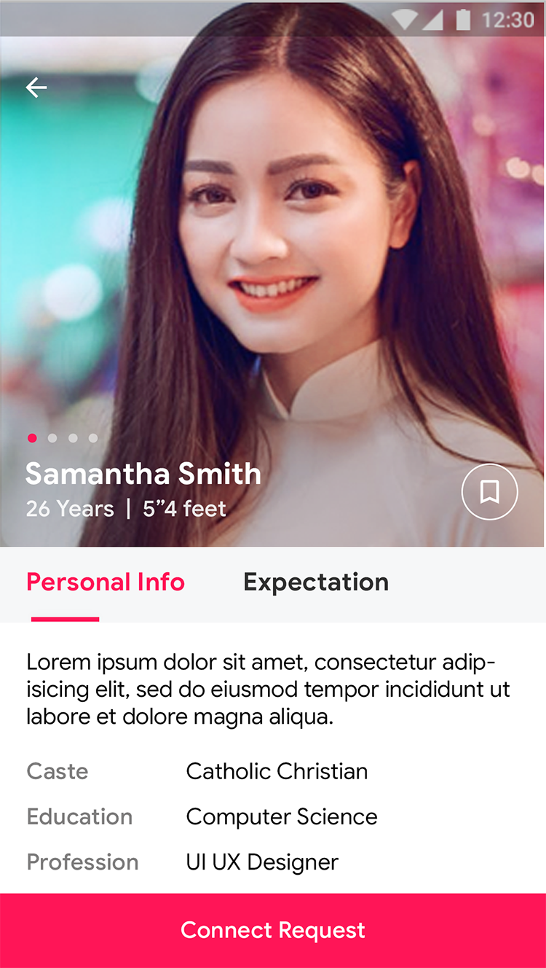

**My Chats**

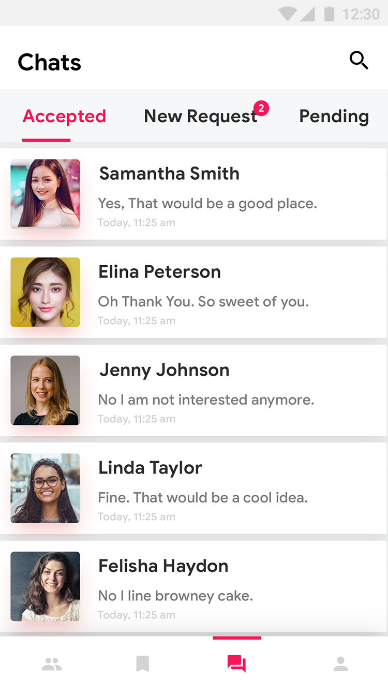

**Messages**

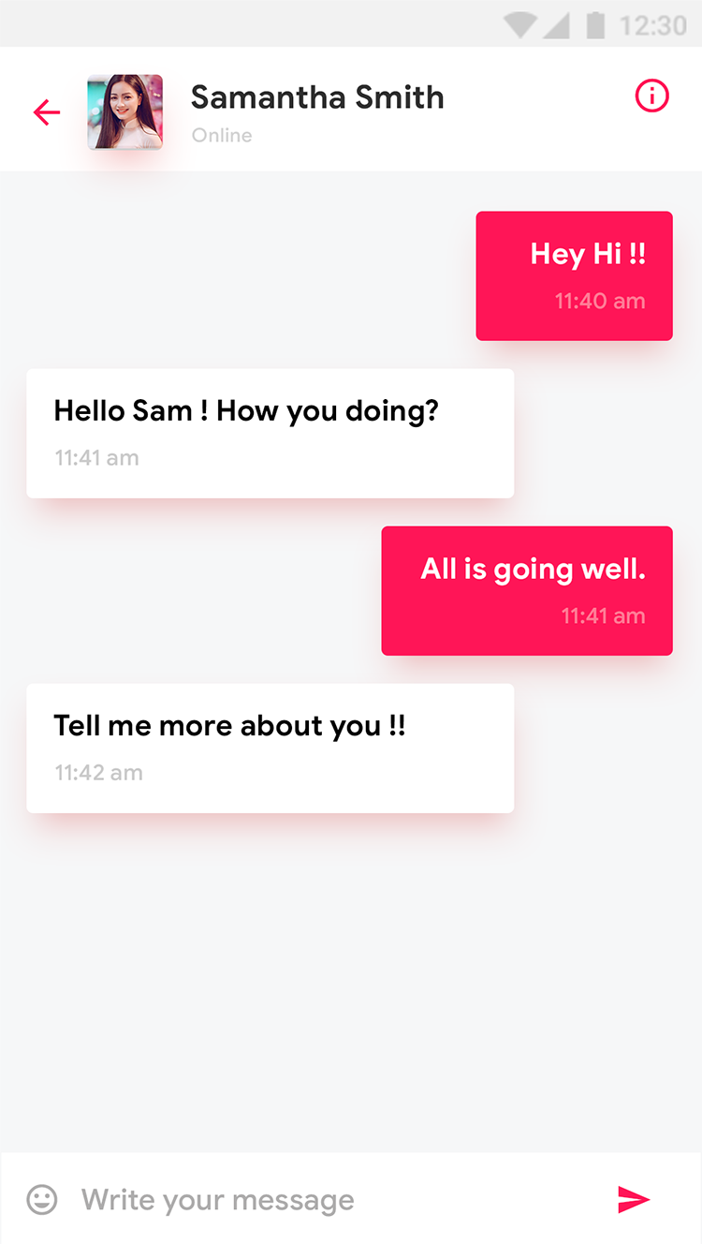

**Subscription Plan**

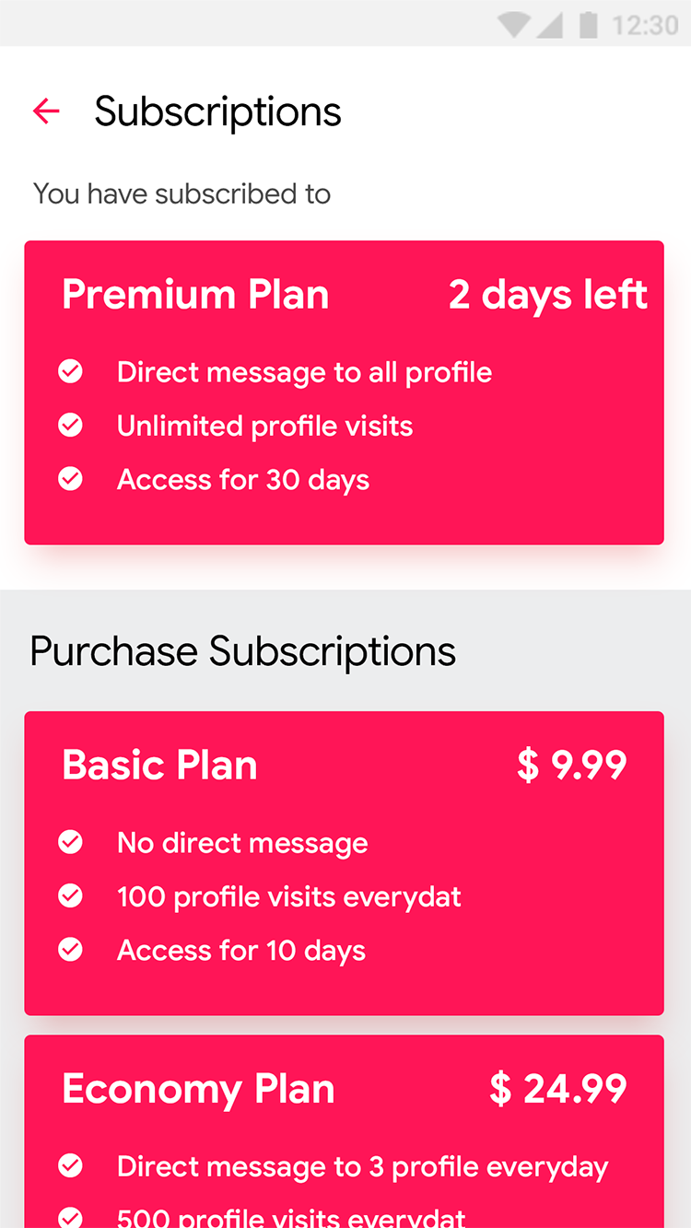

S



# Conclusion

* Matrimony App is mainly developed to let individual find their potential matches for marriage according to their partner preferences
* This application allows the phrase ‘Marriages are made in heaven’ to be rephrased as ‘Marriages are now made online’
* This app provides interested Bride and Grooms across the country to know each other according to their convenience